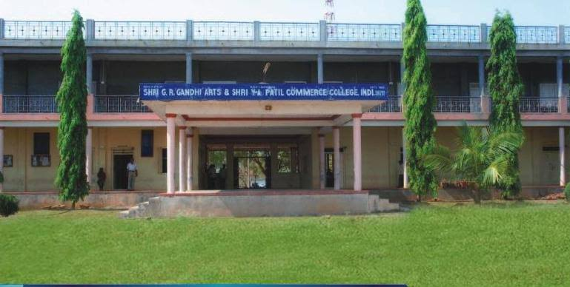
CRITERION VII - INSTITUTIONAL VALUES AND BEST PRACTICES

7.1.4 - Water conservation facilities available in the Institution:
1. Rain water harvesting
2. Bore well /Open well recharge
3. Construction of tanks and bunds
4. Waste water recycling
5. Maintenance of water bodies and distribution system in the campus
7.1.4 Water conservation facilities available in the Institution: (Environmental Consciousness and Sustainability)
WATER CONSERVATION FACILITIES AVAILABLE IN THE INSTITUTION
Shri GRG Arts, Shri YAP Commerce and Shri MFD Science Degree College, INDI is surrounded by more villages. Our College and Pattan Panchayat of Indi took up the initiative to promote water conservation facilities in various social development activities. As, Shri GRG Arts, Shri YAP Commerce and Shri MFD Science Degree College, INDI is located in rural area, there is no Municipal Water supply for the college. The college depends on ground water for all its water needs. Hence, efficient usage of available water and adaptation of water conservation measures are essential. The daily requirement of water in the campus is around 20000 to 30000 litters. The following measures are taken for the conservation of water:
1. RAIN WATER HARVESTING : Rainwater harvesting (RWH) is the collection and storage of rain water, rather than allowing it to run off. Rainwater is collected from a roof-like surface and redirected to a tank, cistern, deep pit (well, shaft, or borehole), aquifer, or a reservoir with percolation, so that it seeps down and restores the ground water. The continues Rainwater Harvesting strategies enable us to use our on-site water resources, which helped to maximize storage of rain water in an integrated needs our college.
2. BOREWELL /OPEN WELL RECHARGE : Water is a prime natural resource and is considered as a precious asset. With every passing day, our dependence on ground water is increasing and is likely to remain dominant. It is clear that College real water lifeline is groundwater. The depletion of groundwater resource is a matter of great concern for college campus. Largescale pumping out of groundwater and negligible recharging has created `water havoc' in the borewell-fed campus.
3. CONSTRUCTION OF TANKS AND BUNDS : Tanks are often surrounded by bund walls which are generally constructed either of earth or concrete. Bunds are particularly important if a tank is located at a higher elevation than the remainder of the facility. A bund is a secondary containment system which is designed to capture any leaks or spillages from a primary containment such as a storage tank. A bund consists of an impermeable floor and a set of impermeable walls to create a watertight area around a storage tank, any liquid which escapes the primary containment is retained in the bund and prevented from spilling onto site or escaping to the environment.
4. WASTE WATER RECYCLING : Water reuse generally refers to the process of using treated wastewater (reclaimed water) for beneficial purposes nonportable applications such as toilet flushing, street washing, and fire protection, groundwater recharge, recreation, and direct or undirected water supply.

4. MAINTENANCE OF WATER BODIES AND DISTRIBUTION SYSTEM IN THE CAMPUS : The College has 04 Borewell for water supply and 01 open pond for rain water harvesting. Water from the Bore well is pumped to the overhead tank of 20000 Lts capacity and Open ground tank of 10000 Lts through 04 pumps. The water from overhead tank is distributed to all taps across the campus and all plants. Water supply for plant is implanted drip system supply. The maintenance of plumbing system is outsourced. Whenever the problems are identified immediate actions are taken for restrict wastage of water. Then plumbers are outsourced to fix the problem.
1. RAIN WATER HARVESTING
RAIN WATER HARVESTING
2. BOREWELL /OPEN WELL RECHARGE
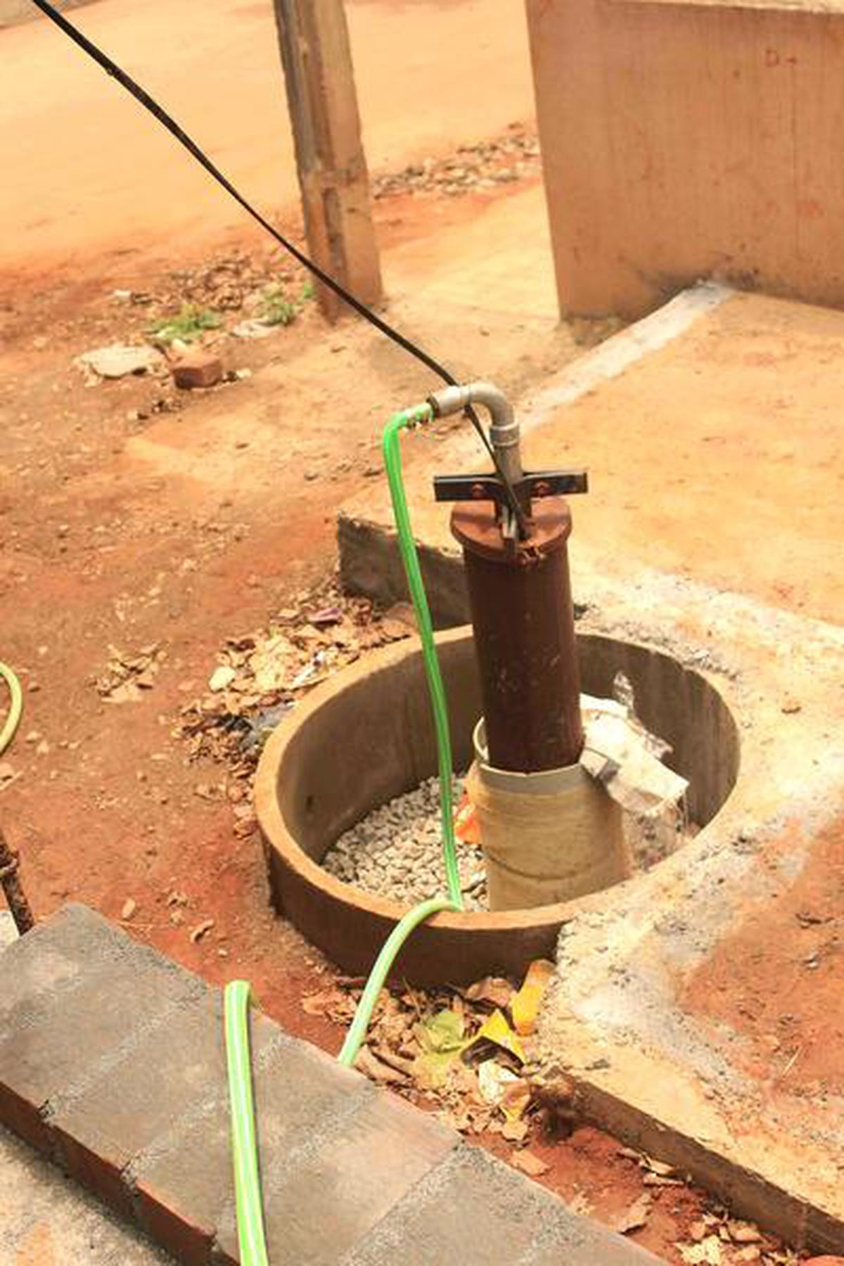

BOREWELL /OPEN WELL RECHARGE
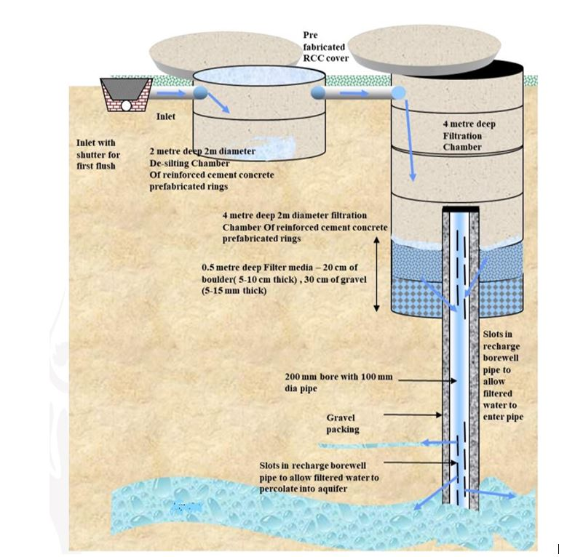

CONSTRUCTION OF TANK
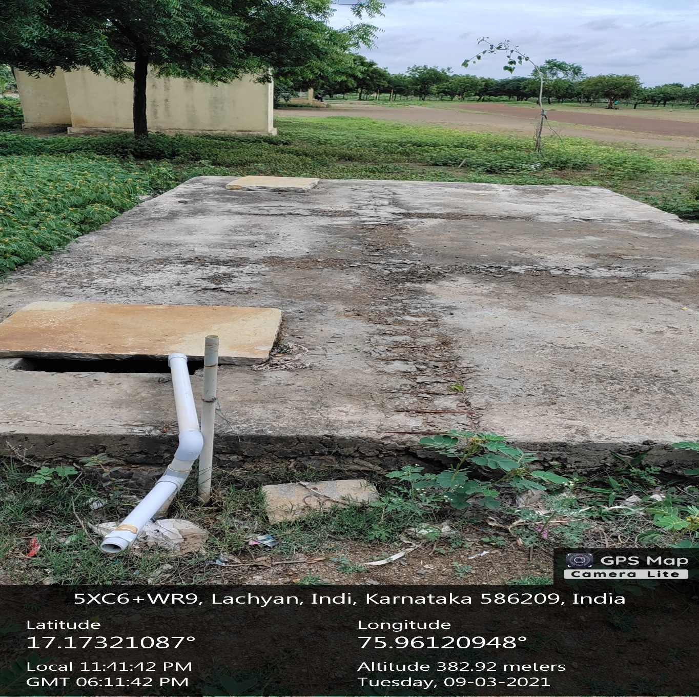

MAINTENANCE OF WATER BODIES AND DISTRIBUTION SYSTEM IN CAMPUS:
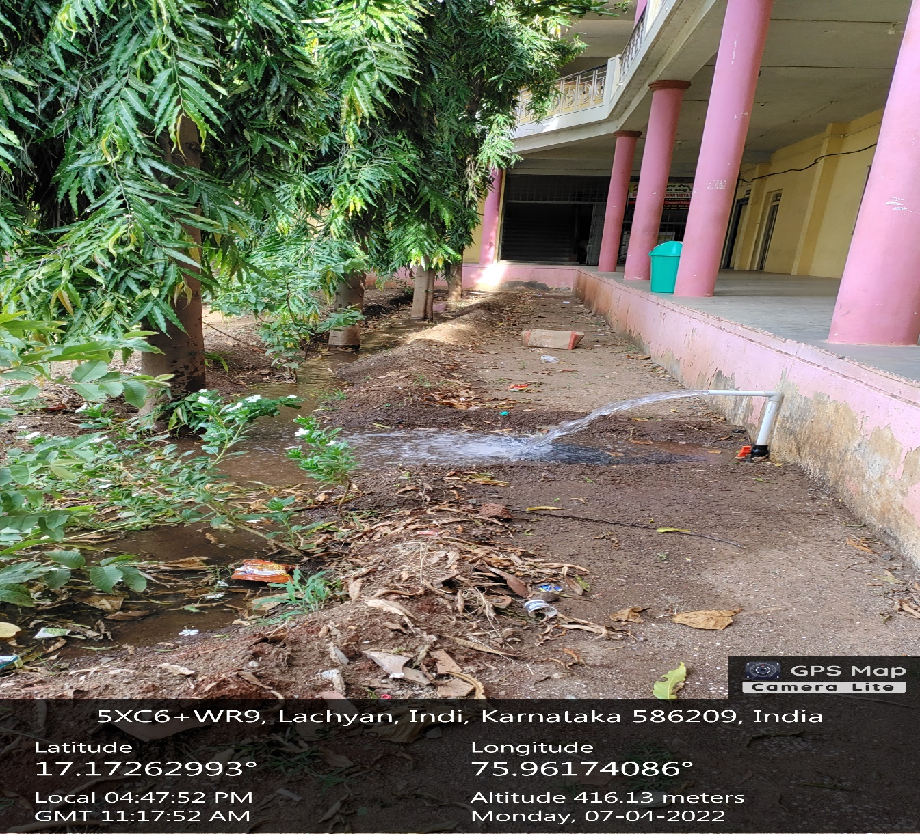

MAINTENANCE OF WATER BODIES AND DISTRIBUTION SYSTEM IN CAMPUS:
